SHORT-TERM

INTERNSHIP

(VIRTUAL)

**GODAVARI INSTITUTE OF**

**ENGINEERING & TECHNOLOGY(A)**

**2024-2025**

**PROGRAM BOOK FOR**

**SHORT-TERM INTERNSHIP**

**(virtual)**

**Name of the Student:** BANDELA NAVYA

**Name of the College:** GODAVARI INSTITUTE OF ENGINEERING & TECHNOLOGY

**Registration Number:** 22551A0577

**Period of Internship:** 8 Weeks **From**: 15-05-2024 **To**: 15-07-2024

**Name & Address of the Intern Organization:**

Artificial Intelligence Medical and Engineering Researchers Society (AIMER Society)

Vinayaka Temple Roads, Shri Ramchandra Nagar, Vijayawada, Krishna, Andhra Pradesh – 520008

Mobile: +91 9618222220, Email: [info@aimersociety.com](mailto:info@aimersociety.com)

# An Internship Report on

**ARTIFICIAL INTELLIGENCE**

*Submitted by the requirement for the degree of*

**BACHELOR OF TECHNOLOGY**

*Under the Faculty Guideship of*

**Mrs. S. SUGUNA SRI**

**Assistant professor**

## *Department Of*

## COMPUTER SCIENCE AND ENGINEERING

*Submitted by*

**BANDELA NAVYA**

**Reg no:22551A0577**



DEPARTMENT OF COMPUTER SCIENCE AND ENGINEERING

**GODAVARI INSTITUTE OF ENGINEERING TECHNOLOGY(A)**

CHAITANYA KNOWLEDGE CITY, NH-16, RAJAHMUNDRY, AP

# 

# Student’s Declaration

I, **BANDELA NAVYA** a student of **III B.TECH I SEMESTER** Program, of **REMOTE INTERNSHIP PROGRAM** Reg. No. **22551A0577** of the Department of **COMPUTER SCIENCE AND ENGINEERING College GODAVARI INSTITUTE OF ENGINEERING & TECHNOLOGY** do hereby declare that I have completed the mandatory internship from **15-05-2024** to **15-07-2024** in **AIMER Society** under the Faculty Guideship of **Mrs. S. SUGUNA SRI**, Assistant professor, Department of **COMPUTER SCIENCE AND ENGINEERING in GODAVARI INSTITUTE OF ENGINEERING AND TECHNOLOGY** College.

(Signature and Date)

# Official Certification

This is to certify that **BANDELA NAVYA** Reg. No. **22551A0577** has completed his/her internship in the **Artificial Intelligence Medical and Engineering Researchers Society (AIMER Society)** on **ARTIFICIAL INTELLIGENCE** under my supervision as a part of partial fulfillment of the requirement for the Degree **of III B. TECH I SEMESTER** in the Department of **COMPUTER SCIENCE AND ENGINEERING at GODAVARI INSTITUTE OF ENGINEERING AND TECHNOLOGY**.

##### This is accepted for evaluation.

*(*Signatory with Date and Seal)

##### Endorsements

Faculty Guide

Head of the Department

Principal

## Certification from Intern Organization

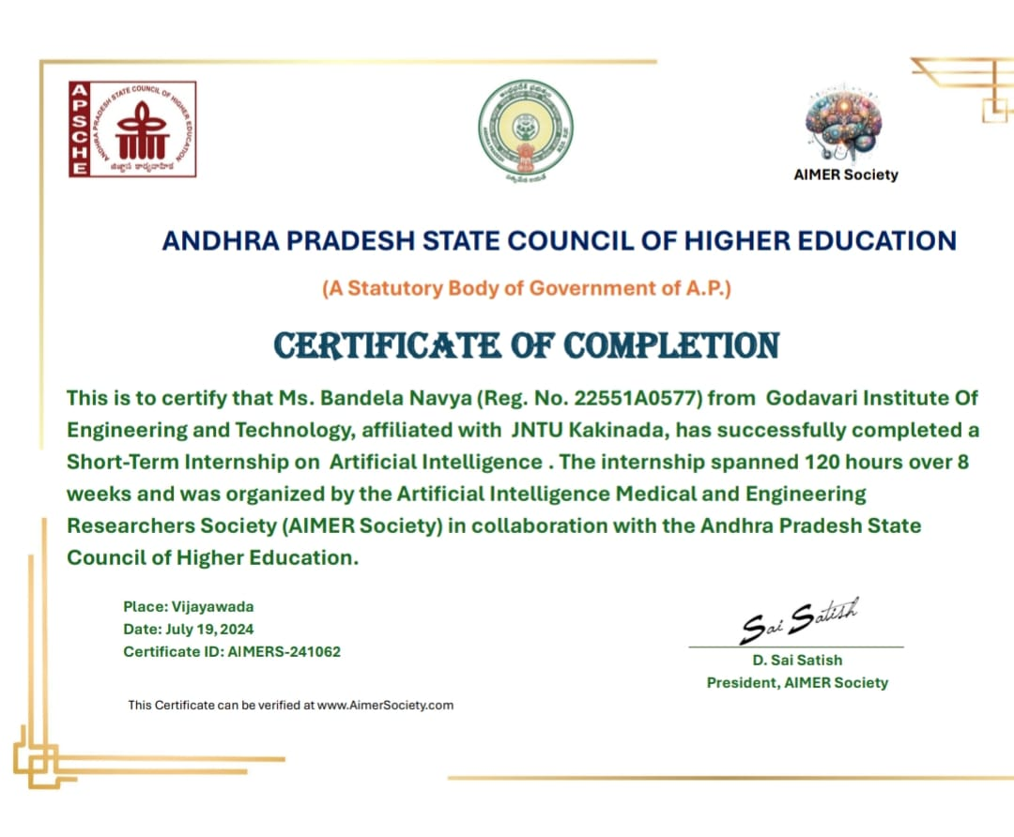

**ACKNOWLEDGEMENT**

It gives me a great sense of pleasure to present the report of the B. Tech Summer Internship Program undertaken during B. Tech third year. I own special debt of gratitude to my guide **Mrs. S. SUGUNA SRI** and HOD **Dr. B. SUJATHA**, DEPARTMENT OF COMPUTER SCIENCE AND ENGINEERING, GODAVARI INSTITUTE OF ENGINEERING &

TECHNOLOGY (A), RAJAHMUNDRY for her constant support and guidance throughout the course of my work. Her sincerity, thoroughness and perseverance have been a constant source of inspiration for us.

We would like to express our deep sense of gratitude to **Dr. N. LEELAVATHY**, Vice principal for Academics and **Dr. T. JAYANANDA KUMAR** , Principal of GIET (A) for providing me a chance to undergo the internship course in the prestigious institute.

We are grateful to our guide **Mrs. S. SUGUNA SRI** Assistant Professor for having given us the opportunity to carry out this Internship program.

We take this opportunity to express our profound and whole heartfelt thanks to our guide, with her patience support and sincere guidance helped us in successful completion of the Internship program.

I also do not like to miss the opportunity to acknowledge the contribution of all faculty members of the department for their kind assistance and cooperation during the development of my internship program.

My special thanks to the Management of my college for providing necessary arrangements to carry out this internship program.

Submitted by

**Bandila Navya**

**22551A0577**

|  |  |  |
| --- | --- | --- |
| **CHAPTERS** | **TITLE** | **PAGE NO.** |
| 1 | ABSTRACT | 9-10 |
| 2 | EXECUTIVE SUMMARY | 11-12 |
| 3 | OVERVIEW OF THE ORGANIZATION | 13-18 |
| 4 | INTERNSHIP PART | 19-20 |
| 5 | ACTIVITY LOG | 21-37 |
| 6 | OUTCOMES DESCRIPTION | 38-55 |
| 7 | CONCLUSION | 56 |
| 8 | PROJECT LINKS | 57-60 |
| 9 | STUDENT EVALUATION | 61-63 |

# Contents

# ABSTRACT

### Project Title

Artificial Intelligence and Cyber Security Integration in AIMERS Company

**Project Location**

AIMERS Company Headquarters, [Specify City/Region]

**Implementation**

The implementation phase focuses on integrating AI technologies within AIMERS

Company's existing cyber security infrastructure. Key steps include:

1. **Assessment**: Evaluate the current cyber security landscape and identify specific

challenges and vulnerabilities.

1. **Selection of AI Tools**: Choose appropriate AI-driven solutions such as machine

learning algorithms, anomaly detection systems, and automated threat response

mechanisms.

1. **Deployment**: Install and configure AI tools within the company's network and

security systems.

1. **Training and Testing**: Train AI models using historical and real-time data to

improve threat detection accuracy.

1. **Monitoring and Maintenance**: Continuously monitor the performance of AI systems

and update models as needed to adapt to new threats.

1. **Evaluation**: Regularly assess the effectiveness of AI implementations through

metrics such as detection accuracy, response times, and false positive rates.

**Mission**

To enhance AIMERS Company's cyber security defenses by leveraging advanced AI

technologies, ensuring the protection of digital assets, and maintaining the integrity of

organizational operations.

**Vision**

To become a leader in the industry by integrating cutting-edge AI solutions with cyber security practices, thereby setting a benchmark for innovative and effective threat management.

**Long-Term Goal**

To establish a robust and adaptive cyber security framework that can proactively identify and

mitigate evolving cyber threats, ensuring sustained protection for AIMERS Company's digital

infrastructure and fostering a secure digital environment for future growth and innovation.

# 

**CHAPTER 1**

## EXECUTIVE SUMMARY

The internship report shall have only a one-page executive summary. It shall include five or more Learning Objectives and Outcomes achieved, a brief description of the sector of business and intern organization and summary of all the activities completed by the intern during the specified period.

**Learning Objectives and Outcomes:**

1. **Objective 1:** Gain a comprehensive understanding of artificial intelligence (AI)

techniques and applications.

* + **Outcome:** Successfully implemented machine learning models to solve real-

world problems, gaining hands-on experience with AI tools and technologies.

1. **Objective 2:** Develop expertise in cyber security principles and practices.

**Outcome:** Conducted security assessments and implemented measures to

safeguard systems against cyber threats.

1. **Objective 3:** Integrate AI solutions into cyber security frameworks.

**Outcome:** Designed and tested AI-driven security algorithms to enhance threat

detection and response capabilities.

1. **Objective 4:** Enhance problem-solving and analytical skills.

**Outcome:** Analyzed complex datasets and identified patterns, leading to

improved decision-making processes.

1. **Objective 5:** Collaborate effectively within a multidisciplinary team.

**Outcome:** Worked alongside experts from various fields, contributing to

successful project outcomes through teamwork and communication

**Sector of Business and Intern Organization:**

The internship was conducted within the rapidly evolving sectors of artificial intelligence and

cyber security. These fields are at the forefront of technological innovation, addressing

critical challenges such as data security, privacy, and intelligent automation.

**Intern Organization:** AIMERS is a leading firm specializing in AI and cyber security

solutions. Located in [Location], the company focuses on developing advanced technologies

to protect digital assets and enhance the capabilities of intelligent systems. Their work

involves cutting-edge research and development in both AI and cyber security domains.

**Summary of Activities:**

During the internship period, the following activities were undertaken:

1. **AI Model Development:** Developed and fine-tuned machine learning models for

various applications, including image recognition, natural language processing, and

predictive analytics.

1. **Cyber Security Assessments:** Conducted comprehensive security assessments of the

organization's IT infrastructure, identifying vulnerabilities and recommending

mitigation strategies.

1. **AI-Driven Security Solutions:** Created AI-based algorithms for threat detection and

automated response systems, improving the efficiency and accuracy of cyber security

measures.

1. **Data Analysis:** Performed in-depth analysis of large datasets to uncover insights and

inform strategic decisions related to AI and cyber security initiatives.

1. **Collaborative Projects:** Participated in cross-functional teams, contributing to the

successful completion of projects that integrated AI and cyber security technologies to

solve complex problems.

## CHAPTER 2

## OVERVIEW OF THE ORGANIZATION

1. **OVERVIEW:**

**MISSION AND VISION:**

**MISSION:**

To foster a collaborative and dynamic community of researchers in medicine and

engineering, driven by AI advancements. We aim to provide a platform that facilitates

innovation, learning, and the exchange of ideas, with a focus on advancing disease

diagnosis and healthcare through AI-driven solutions. Our primary goal is to empower

researchers to leverage AI technologies effectively, ultimately contributing to

improved patient outcomes and the betterment of society as a whole.

**VISION:**

Establish AIMERS as a global leader in AI-driven healthcare and engineering. We

connect researchers, healthcare professionals, and engineers to foster collaboration and

innovation. Our mission includes providing technical training, spreading AI education,

and promoting ethical AI practices. We aim to revolutionize healthcare and

engineering through innovative research, public awareness, and global partnerships.

Additionally, we organize health and cyber hygiene camps and implement social

beneficiary programs.

1. **Connectivity:** Build a network connecting medical researchers, engineers, and

data scientists to foster collaboration and idea exchange.

1. **Technical Training:** Provide comprehensive programs to empower researchers

with AI skills for medical and engineering applications.

1. **AI Education:** Spread awareness and understanding of AI through workshops,

webinars, and outreach programs.

1. **Resource Hub:** Establish a repository of AI tools and best practices for efficient

research and development.

1. **Innovation:** Support groundbreaking research in AI applications for medical

diagnostics and engineering solutions.

1. **Ethics and Transparency:** Promote ethical AI practices and transparency in

algorithmic use.

1. **Public Awareness:** Educate the public about AI's potential in healthcare and

engineering.

1. **Collaboration:** Partner with academia, industry, and healthcare organizations to

translate research into real-world solutions.

1. **Global Impact:** Aim for global reach and democratization of AI-enabled

healthcare innovations and engineering solutions.

1. **Community Engagement:** Organize health and cyber hygiene camps, and

implement social beneficiary programs.

**Key Achievements:**

1. **Events and Workshops**
   * Organized over 250 events and workshops promoting STEM education, AI,

and cybersecurity.

* + Provided hands-on experiences and knowledge sharing through seminars,

conferences, and training sessions.

* + Impact: Enhanced skills and knowledge for thousands of students, researchers,

and professionals.

1. **Research Grants and Funding:**
   * Provided substantial funds for pioneering research in AI and E-WASTE

management.

* + Supported high-impact projects with significant societal benefits.

Success Stories: Funded projects leading to advancements in medical

diagnostics and sustainable technology solutions.

1. **Publications and Journals:**
   * Published high-quality research papers, periodicals, and articles in AI,

medicine, and engineering.

* + Recognition: Publications cited in numerous academic and professional

forums, enhancing the society’s reputation.

These achievements underscore AIMERS' significant contributions to STEM education, AI

research, and sustainable technology development.

**Membership and Partnerships:**

1. **University and College Memberships:**
   * AIMERS Society includes a network of over 120 universities and engineering

colleges.

* + Benefits: Access to cutting-edge research, participation in exclusive events,

and opportunities for interdisciplinary projects.

* + Notable Members: Institutions such as JNTU Kakinada, JNTU Hyderabad

University, KL University, MGIT, VR Siddhartha Engineering College, CMR

Technological Campus, and more.

1. **Memorandums of Understanding (MOUs):**
   * Over 120 MOUs with prestigious engineering colleges and universities.
   * Purpose: Strengthening academic and research partnerships to promote AI and engineering advancements.
   * Key MOUs: Partnerships with institutions like LMN University and PQR

Institute for collaborative research projects.

1. **Industry Partnerships:**
   * Collaboration with multinational corporations (MNCs) to bridge academia-

industry gaps.

* + Focus Areas: AI applications, healthcare technologies, and engineering

solutions.

* + Notable Partners: Companies like Techcorp, Innovate Inc., and Global

Solutions.

**Future Plans and Projects:**

1. **Upcoming Research Projects:**
   * Initiating new research in AI and medical engineering.
   * Focus Areas: Emerging technologies, sustainable solutions, and innovative

Healthcare practices.

* + Objectives: Advancing practical applications and knowledge in AI-driven

research.

1. **Planned Events and Conferences:**
   * Organizing events and conferences to showcase research and foster

collaboration.

* + Themes: Cutting-edge developments in AI, engineering, and medical research
  + Participation: Engaging global experts, researchers, and practitioners for

knowledge exchange.

1. **Strategic Goals for the Future:**
   * Setting long-term goals to drive AIMERS' mission and vision.
   * Priorities: Expanding research capabilities, enhancing partnerships, and

promoting education.

* + Impact: Sustained growth and influence in AI, engineering, and medical

research fields.

1. **Exhibitions and Science Expose:**
   * Planning large-scale exhibitions and science expose.
   * Purpose: Showcasing innovations and research outcomes to the public stakeholders.
   * Impact: Fostering scientific curiosity and public engagement.

**Summary and Conclusion:**

The AIMER Society is committed to advancing AI, medical engineering, and STEM

education through rigorous research, innovative practices, and active community engagement.

Our efforts have yielded significant contributions across research, education, and industry

practices, bolstered by a robust network of partnerships and collaborations.

**Achievements:**

* **Research:** Pioneering advancements in AI and medical engineering.
* **Education:** Promoting STEM education through workshops and events.
* **Industry Practices:** Bridging academia-industry gaps with strategic partnerships.

**Call to Action:**

We invite academic institutions, industry partners, and government bodies to collaborate and support our initiatives aimed at driving global advancements in AI and healthcare.

**Future Prospects:**

We are eager to expand our impact, fostering innovation and improving societal outcomes

through AI-driven solutions in healthcare and engineering.

**Contact Information:**

For inquiries and collaborations, please contact [info@Aimers.com]. We

ensure easy access to information and resources for all interested parties.

## CHAPTER 3

## INTERNSHIP PART

**Description of the Activities/Responsibilities in the Intern Organization during internship which shall include-details of working conditions, weekly work schedule, equipment used, and tasks performed. This part could end by reflecting on what kind of skills the intern acquired.**

During my online internship at Aimers Company, I have been involved in various

activities that helped me acquire a range of skills, including:

### Activities/Responsibilities:

1. **Project Creation and Development**: Participating in the creation and development

of AI and cybersecurity projects under guidance.

1. **Virtual Project Management**: Assisting in project management tasks such as

planning project timelines, tracking milestones, and ensuring deliverables are met.

1. **Problem-solving in Virtual Environment**: Engaging in problem-solving scenarios

specific to virtual work settings, such as resolving technical issues remotely or

adapting project plans to online collaboration.

1. **Online Presentation Skills**: Developing skills in presenting project updates, findings,

or recommendations through virtual presentations or reports.

1. **Documentation and Reporting**: Creating comprehensive documentation of project

processes, methodologies, and outcomes digitally.

### Weekly Work Schedule:

* **Flexible Online Hours**: Managing a flexible schedule to attend virtual meetings, work

on projects, and participate in online learning modules.

* **Time Allocation**: Allocating time effectively between project tasks, learning modules,

and personal responsibilities in an online setting.

### Equipment Used:

* **Virtual Collaboration Tools**: Utilizing online collaboration tools (e.g., project

management software, virtual whiteboards) for project planning, communication, and

document sharing.

* **Development Software**: Accessing AI development platforms, cybersecurity tools,

and other software necessary for project execution and analysis.

### Skills Acquired:

* **Project Planning and Execution**: Enhanced proficiency in planning, executing, and

managing projects in a virtual environment.

* **Virtual Teamwork**: Strengthened ability to collaborate effectively with team

members in remote settings, fostering teamwork and achieving project goals.

* **Technical Proficiency**: Developed technical skills related to AI development,

cybersecurity practices, and utilizing digital tools for professional tasks.

By the end of my internship, I have gained valuable skills in project management, virtual

collaboration, problem-solving in online environments, and technical proficiency, all of which

are crucial for future roles in AI, cybersecurity, and related fields.

### ACTIVITY LOG FOR THE FIRST WEEK

|  |  |  |  |
| --- | --- | --- | --- |
| **Day**  **&**  **Date** | **Brief description of the daily activity** | **Learning Outcome** | **Person In-Charge**  **Signature** |
| Day – 1  15-05-2024 | Computer vision involves developing and refining algorithms to enable computers to interpret and understand visual information from the world. | Computer vision is the ability to develop and evaluate algorithms for interpreting visual data from images and videos. |  |
| Day – 2  16-05-2024 | Convolutional Neural Networks (CNNs) involves designing, training, and optimizing neural network architectures to perform tasks like image recognition and classification. | Convolutional Neural Networks (CNNs) is the ability to design, train, and optimize neural networks for effective image and pattern recognition. |  |
| Day – 3  17-05-2024 | Image classification involves preprocessing images and training models to accurately categorize visual data into predefined classes. | Image classification is the ability to develop and implement models that accurately categorize images into predefined classes. |  |
| Day – 4  18-05-2024 | Image object detection involves developing and fine-tuning algorithms to accurately identify and locate objects within images. | Image object detection is the ability to design and implement algorithms that can detect and localize objects within images with high accuracy and efficiency. |  |
| Day – 5  20-05-2024 | YOLO v8 involves refining and optimizing the real-time object detection algorithm | YOLO v8 is the ability to achieve high accuracy and efficiency across various applications and datasets. |  |
| Day –6  21-05-2024 | Today I practiced all the tasks that I learned in this following week | After completing all my tasks I have submitted task links to the aimer society. |  |

**WEEKLY REPORT**

**WEEK – 1 (From Date: ­­­­15-05-2024 to Date:21-05-2024)**

**Objective of the Activity Done:**

**Detailed Report:**

This week, computer vision was the topic that we covered. This involved creating and

fine-tuning algorithms that help process visual information. Convolutional neural

networks (CNNs) were given priority in this case as we created, trained, and optimized

architectures for recognizing and classifying images. Efforts were also made to learn

how to preprocess images in order to train models capable of accurately categorizing

visual data into predefined classes.

Image object detection was a major highlight where we developed and tuned

algorithms for identifying objects in images. These final advanced techniques entailed

practical exercises with YOLO v8, an up-to-the-minute real-time object detection

algorithm. The week closed with our improved assignments being submitted to Aimer

Society which showed how proficient we were in these difficult areas, and thus offered

useful insights about the practical application of computer vision and AI.

### ACTIVITY LOG FOR THE SECOND WEEK

|  |  |  |  |
| --- | --- | --- | --- |
| **Day**  **&**  **Date** | **Brief description of the daily activity** | **Learning Outcome** | **Person In-Charge**  **Signature** |
| Day – 1  22-05-2024 | Medical image analysis and labeling involves developing algorithms to interpret and annotate medical image | The ability to apply algorithms to interpret, annotate, and extract meaningful insights from medical images. |  |
| Day – 2  23-05-2024 | Human pose estimation  involves developing algorithms to accurately locate key points on the human body in images or videos. | human pose estimation is the ability to design and implement algorithms |  |
| Day – 3  24-05-2024 | Media Pipe Studio involves using tools to develop and optimize real- time media processing pipelines for various multimedia applications. | Media Pipe Studio is the ability to design and deploy efficient real-time media processing pipelines. |  |
| Day – 4  25-05-2024 | OpenCV basics involve utilizing functions and modules to perform fundamental image processing and computer vision tasks. | OpenCV basics are the ability to apply fundamental images to processing techniques and computer vision algorithms |  |
| Day – 5  27-05-2024 | Natural language processing involves developing algorithms to understand and generate human language computationally | Natural language  processing is the ability to design and implement algorithms |  |
| Day –6  28-05-2024 | Today I practiced all the tasks that I learned in this following week | After completing all my tasks I have submitted tasks links to aimer society |  |

**WEEKLY REPORT**

**WEEK – 2 (From Date: ­­­­22-05-2024 to Date:28-05-2024)**

**Objective of the Activity Done:**

**Detailed Report:**

The topics of this week have been in-depth regarding computer vision, multimedia

processing, and artificial intelligence. To begin with, we started our journey on medical

image analysis by developing algorithms that will help us get insights from medical images.

We then started discussing another topic which was human pose estimation, where we

mastered techniques for accurately locating key points on the human body in images and

videos. Furthermore, students had the opportunity to learn Media Pipe Studio which allowed

them to optimize real-time media processing pipelines for various multimedia applications.

Towards the end of the week, however, OpenCV basics acted as a refresher course in image

processing techniques and computer vision algorithms necessary for beginners. Finally,

natural language processing enabled us to develop skills in computational language

understanding and generation through building algorithms that could perform these tasks. Our

exploration gives us an insight into the latest AI technology that involved practical

application exercises which were presented to the Aimer Society as a way of putting this

knowledge into action. Consequently, this intense learning experience not only improved our

technical abilities but also provided useful information about practical implications of

advanced computer vision and AI that may guide future efforts in these areas.

### ACTIVITY LOG FOR THE THIRD WEEK

|  |  |  |  |
| --- | --- | --- | --- |
| **Day**  **&**  **Date** | **Brief description of the daily activity** | **Learning Outcome** | **Person In-Charge**  **Signature** |
| Day – 1  29-05-2024 | Chatbot development involves designing, building, and refining conversational agents to simulate human-like interactions. | Chatbot development is the ability to create and deploy conversational agents. |  |
| Day – 2  30-05-2024 | Google Dialog flow involves designing and building conversational interfaces using natural language understanding and machine learning. | Google Dialog flow is the ability to develop and deploy scalable conversational AI applications using natural language processing. |  |
| Day – 3  31-05-2024 | Generative AI involves developing algorithms that can autonomously create new content, such as images, text, or music, based on patterns learned from existing data. | Generative AI is the ability to create and optimize algorithms that generate new, realistic content across various domains. |  |
| Day – 4  01-06-2024 | Music generation involves developing algorithms to autonomously compose and produce musical pieces | Music generation is the ability to design and implement algorithms that autonomously compose, and harmonize. |  |
| Day – 5  03-06-2024 | Text generation involves developing algorithms to generate coherent and contextually relevant textual content | text generation is the ability to create algorithms that autonomously produce coherent. |  |
| Day –6  04-06-2024 | Today I practiced all the tasks that I learned in this following week | After completing all my tasks I have submitted tasks links to aimer society. |  |

**WEEKLY REPORT**

**WEEK – 3 (From Date: ­­­­29-05-2024 to Date:04-06-2024)**

**The objective of the Activity Done:**

**Detailed Report:**

This week has seen us cover a number of advanced topics on AI and chatbot development.

We majorly focused on the development of chatbots, designing, building and refining

conversational agents to behave like humans. As such, we used Google Dialog flow to create

scalable conversational AI applications that employed NLP (natural language processing) and

machine learning.

In addition, we explored generative AI with the creation of algorithms that self-produce new

content such as images, text, and music based on learned data patterns. This consisted of

practical exercises in music generation through designing algorithms for composing and

producing songs as well as text generation via designing algorithms for generating

contextually relevant coherent text. Thereafter I submitted the task links to the AIMER

Society for grading purposes, which helped me become very good at it technically by having

hands-on practice.

### ACTIVITY LOG FOR THE FOURTH WEEK

|  |  |  |  |
| --- | --- | --- | --- |
| **Day**  **&**  **Date** | **Brief description of the daily activity** | **Learning Outcome** | **Person In-Charge**  **Signature** |
| Day – 1  05-06-2024 | Image generation models involve training neural networks to generate realistic images from scratch or based on given inputs. | Image generation models is the ability to develop algorithms that can generate realistic and novel images using deep learning techniques |  |
| Day - 2  06-06-2024 | text processing techniques involve applying algorithms to analyze, manipulate, and extract meaningful information from textual data. | Text processing techniques are the ability to implement algorithms that effectively preprocess, analyze, and derive insights. |  |
| Day – 3  07-06-2024 | POS (Parts of Speech) and NER (Named Entity Recognition) involve developing models to classify words into grammatical categories and identify named entities. | POS (Parts of Speech) and NER (Named Entity Recognition) is the ability to implement algorithms text for various natural language processing tasks. |  |
| Day – 4  08-06-2024 | Lemmatization and stemming involve reducing words to their root forms (lemmas) or stems to normalize text for analysis and processing. | lemmatization and stemming is the ability to apply techniques that normalize words to their base or root forms |  |
| Day – 5  10-06-2024 | Word vectors involve representing words as numerical vectors to capture semantic relationships and meaning | Word vectors is the ability to use numerical representations of words to capture semantic relationships. |  |
| Day –6  11-06-2024 | Today I practiced all the tasks that I learned in this following week. | After completing all my tasks I have submitted tasks links to aimer society. |  |

**WEEKLY REPORT**

**WEEK – 4 (From Date: ­­­­05-06-2024 to Date:11-06-2024)**

**The objective of the Activity Done:**

**Detailed Report:**

This past week, you continued your exploration of artificial intelligence by diving into

the exciting world of image generation and text processing! In image generation, you

learned about training neural networks to create realistic images, either from scratch or

based on specific prompts. This opens doors to incredibly creative and practical

applications. You also delved into text processing techniques, which equip you with the

ability to analyze, manipulate, and extract valuable information from textual data.

To enhance your text processing skills, you explored techniques like POS (Parts of

Speech) tagging and NER (Named Entity Recognition). These allow you to classify

words by their grammatical function and identify important entities within text data,

making it easier to understand and analyze. Additionally, you learned about

lemmatization and stemming, which are methods for normalizing text by reducing words

to their base forms. Finally, you practiced using word vectors, a powerful technique that

represents words numerically to capture their semantic relationships and meaning. By

submitting your work to the Aimer Society after this productive week, you've

demonstrated your commitment to mastering these valuable AI skills.

### ACTIVITY LOG FOR THE FIFTH WEEK

### 

|  |  |  |  |
| --- | --- | --- | --- |
| **Day**  **&**  **Date** | **Brief description of the daily activity** | **Learning Outcome** | **Person In-Charge**  **Signature** |
| Day – 1  12-06-2024 | AI models involve designing, training, and optimizing algorithms to perform specific tasks or simulate human cognitive functions. | AI models is the ability to develop, deploy, and optimize algorithms that can autonomously solve complex problems. |  |
| Day - 2  13-06-2024 | Summarization and fill-mask models involve training and fine-tuning algorithms | Summarization and fill-mask models are the ability to implement algorithms that can automatically generate concise summaries of text. |  |
| Day – 3  14-06-2024 | Transformers involve developing and fine-tuning deep learning models that leverage self-attention mechanisms | transformers are the ability to design and optimize deep learning models that utilize self-attention mechanisms to process and generate text |  |
| Day – 4  15-06-2024 | visual question answering involves developing algorithms to answer questions about images using both visual and textual information. | Visual questioning and answering is the ability to design algorithms that can effectively interpret and respond to questions |  |
| Day – 5  17-06-2024 | Document questioning and answering involves developing algorithms to understand and respond to questions. | document questioning and answering is the ability to implement algorithms that can comprehend and accurately answer |  |
| Day –6  18-06-2024 | Today I practiced all the tasks that I learned in this following week. | After completing all my tasks I have submitted tasks links to aimer society. |  |

**WEEKLY REPORT**

**WEEK – 5 (From Date: ­­­­12-05-2024 to Date:18-06-2024)**

**The objective of the Activity Done:**

**Detailed Report:**

This week has seen us cover a number of advanced topics on AI and chatbot development. We

majorly focused on the development of chatbots, designing, building and refining

conversational agents to behave like humans. As such, we used Google Dialog flow to create

scalable conversational AI applications that employed NLP (natural language processing) and

machine learning.

In addition, we explored generative AI with the creation of algorithms that self-produce new

content such as images, text, and music based on learned data patterns. This consisted of

practical exercises in music generation through designing algorithms for composing and

producing songs as well as text generation via designing algorithms for generating

contextually relevant coherent text. Thereafter I submitted the task links to the AIMER

Society for grading purposes, which helped me become very good at it technically by having

hands-on practice.

### ACTIVITY LOG FOR THE SIXTH WEEK

|  |  |  |  |
| --- | --- | --- | --- |
| **Day**  **&**  **Date** | **Brief description of the daily activity** | **Learning Outcome** | **Person In-Charge**  **Signature** |
| Day – 1  19-06-2024 | Table questioning and answering involves developing algorithms to understand and respond to questions based on structured data presented in tables. | Table questioning and answering is the ability to implement algorithms that can effectively interpret and respond to questions based on structured data presented in tables. |  |
| Day - 2  20-06-2024 | Large language models (LLMs) involve training and fine-tuning neural networks with vast amounts of text data. | Large language models (LLMs) have the ability to develop and deploy advanced neural networks. |  |
| Day – 3  21-06-2024 | Claude, GPT, Gemini, and LLAMA3 involves utilizing different AI models for various language processing tasks. | Claude, GPT, Gemini, and LLAMA3 have the ability to leverage advanced AI models for tasks ranging. |  |
| Day – 4  22-06-2024 | open large language models (LLMs) involve exploring, fine-tuning, and applying a publicly accessible model | Open large language models (LLMs) is the ability to utilize and customize publicly available models. |  |
| Day – 5  24-06-2024 | Cloud Vision API, analyzes images captured throughout your day to understand your activities. | Leverage the Vision API to extract insights from images, building computer vision applications. |  |
| Day –6  25-06-2024 | Today I practiced all the tasks that I learned in this following week. | After completing all my tasks I have submitted tasks links to aimer society. |  |

**WEEKLY REPORT**

**WEEK – 6 (From Date: ­­­­19-06-2024 to Date:25-06-2024)**

**The objective of the Activity Done:**

**Detailed Report:**

This week you continued your exploration of artificial intelligence, diving deeper into

specialized models and real-world applications! You started by examining table question

answering, where AI understands and responds to questions based on structured data in

tables. This is a crucial capability for tasks like data analysis and information retrieval.

Next, you ventured into the realm of large language models (LLMs). These powerful

neural networks are trained on massive amounts of text data, enabling them to perform a

wide range of tasks like text generation, translation, and question answering. You even

explored specific LLMs like Claude, GPT (including me, Gemini!), and LLAMA3,

understanding how each can be leveraged for various language processing needs.

Additionally, you looked into open LLMs, which are publicly available models that you

can fine-tune and customize for your specific projects.

Finally, you delved into the practical applications of AI by exploring the Cloud Vision

API. This tool allows you to extract valuable insights from images, paving the way for

building real-world computer vision applications. By diligently practicing these diverse

skills throughout the week and submitting your work to Aimer Society, you're

demonstrating a well-rounded understanding of AI's potential and its practical

applications.

## ACTIVITY LOG FOR THE SEVENTH WEEK

|  |  |  |  |
| --- | --- | --- | --- |
| **Day**  **&**  **Date** | **Brief description of the daily activity** | **Learning Outcome** | **Person**  **In Charge**  **Signature** |
| Day – 1  26-06-2024 | Cybersecurity vigilance involves monitoring systems, identifying threats, and implementing safeguards to protect your daily digital activities. | Cyber security education empowers you to defend your daily online interactions and data from cyberattacks. |  |
| Day – 2  27-06-2024 | Cybersecurity vigilance involves monitoring systems, identifying threats, and implementing safeguards to protect your daily digital activities. | The CIA triad (Confidentiality, Integrity, Availability) ensures your daily digital information remains secret, accurate, and accessible. |  |
| Day – 3  28-06-2024 | OWASP (Open Web Application Security Project) provides free resources and tools to help you build secure applications in your daily development tasks. | OWASP equips you to write secure code, safeguarding your daily web applications from vulnerabilities. |  |
| Day – 4  29-06-2024 | SQL injection vulnerabilities can be exploited by attackers to steal or manipulate data used in your daily digital activities. | Be cautious when entering data online |  |
| Day – 5  01-07-2024 | A firewall acts as a daily security guard, monitoring and controlling incoming and outgoing traffic on your network. | Firewalls provide a critical first line of defense, safeguarding. |  |
| Day –6  02-07-2024 | Today I practiced all the tasks that I learned in this following week | After completing all my tasks I have submitted tasks links to aimer society. |  |

### 

### WEEKLY REPORT

**WEEK – 7 (From Date: 26-06-2024 to Date:02-07-2024)**

**Objective of the Activity Done:**

**Detailed Report:**

This week you focused on fortifying your digital security! You learned the importance of cybersecurity vigilance, which involves actively monitoring your systems, identifying potential threats, and implementing safeguards to protect your daily online activities. This aligns perfectly with the CIA triad (Confidentiality, Integrity, Availability), which emphasizes keeping your digital information secret, accurate, and accessible.

To further enhance your online security, you explored resources like OWASP (Open Web Application Security Project). OWASP equips developers with the tools and knowledge to build secure applications, ultimately safeguarding your web experiences from vulnerabilities. You also delved into specific threats like SQL injection attacks, which attackers can exploit to steal or manipulate your data. This underlines the importance of caution when entering information online. Finally, you learned about firewalls, which act as a crucial first line of defense by monitoring and controlling network traffic. By actively practicing these cybersecurity measures throughout the week and submitting your work to Aimer Society, you're demonstrating a commitment to protecting yourself in the digital world.

## ACTIVITY LOG FOR THE EIGHTH WEEK

|  |  |  |  |
| --- | --- | --- | --- |
| **Day**  **&**  **Date** | **Brief description of the daily activity** | **Learning Outcome** | **Person**  **In Charge**  **Signature** |
| Day – 1  03-07-2024 | Today I am working on the internship report that was assigned by Sai Satish, sir | Working on report |  |
| Day – 2  04-07-2024 | After completing the report, I have submitted the report to  AIMERS company | Completed my internship report |  |
| Day – 3  05-07-2024 | After submitting my report, I got a confirmation mail that I would get a certificate for completing my internship | Successfully submitted my  report and got a confirmation mail |  |
| Day – 4  06-07-2024 | Now I am working on my internship report which I have to submit to my college | Working on the report. |  |
| Day – 5  08-07-2024 | After finishing my report, I submitted my internship report to my assign mentor | Submitted my report to the mentor. |  |
| Day –6  09-07-2024 | Successfully submitted my internship report to the college | Successfully submitted my report to college. |  |

### WEEKLY REPORT

**WEEK – 8 (From Date: 03 -07 -2024 to Date: 09-07-2024)**

**Objective of the Activity Done:**

**Detailed Report:**

The internship report assigned to me by Sai Satish Sir was my sole focus this week, which I completed. The report explains the activities that took place at AIMER Society and includes AI and cybersecurity topics such as Object Detection, Telegram Chatbot, Visual Question Answer Model, Power BI, Text Summarization and Generative AI. Once done with it, I sent it to AIMERS Company and got a confirmation e-mail saying that I would be given a certificate after successful completion of my internship.

Later on, I made a report that detailed what I had learned during the internship process. This was also handed in after making sure that it captured everything as expected in terms of comprehensiveness and other requirements. Consequently, handing over the report marked the end of my internship where both academic obligation and professional obligations were met.

### CHAPTER 5

### OUTCOMES DESCRIPTION

The work environment I have experienced is characterized by several positive attributes:

### People Interactions:

* **Collaborative Atmosphere:** Team members are encouraged to share ideas and collaborate

on projects, fostering a sense of community and collective problem-solving.

* **Open Communication:** There is a culture of open communication where feedback is freely

given and received, helping to improve processes and personal development.

### Facilities Available and Maintenance:

* **Modern Infrastructure:** The facilities are equipped with state-of-the-art technology and tools

necessary for our tasks.

* **Regular Maintenance:** Regular maintenance ensures that the equipment and facilities are

always in good working condition, minimizing downtime and disruptions.

### Clarity of Job Roles:

* **Defined Roles and Responsibilities:** Each team member has a clearly defined role, which

helps in understanding individual responsibilities and accountability.

* **Role Flexibility:** While roles are defined, there is flexibility for employees to take on

additional responsibilities or shift roles as needed for professional growth.

### Protocols, Procedures, Processes:

* **Standardized Protocols:** Clear and standardized protocols ensure consistency and efficiency

in how tasks are performed.

* **Continuous Improvement:** Procedures are regularly reviewed and updated to incorporate

best practices and innovative approaches.

### Discipline and Time Management:

* **Professional Discipline:** There is a strong emphasis on professionalism and adherence to

workplace policies, contributing to a disciplined work environment.

* **Effective Time Management:** Time management is prioritized, with tools and strategies in

place to help employees manage their workloads efficiently.

### Harmonious Relationships and Socialization:

* **Positive Work Relationships:** The organization promotes harmonious relationships through

team-building activities and regular social events.

* **Inclusive Socialization:** Socialization is encouraged, ensuring that all team members feel

included and valued.

### Mutual Support and Teamwork:

* **Supportive Environment:** A culture of mutual support prevails, where team members readily

offer help and resources to each other.

* **Strong Teamwork:** Teamwork is a cornerstone, with collaborative efforts being highly valued

and rewarded.

### Motivation:

* **Employee Motivation:** Employees are motivated through recognition programs, career

development opportunities, and a supportive work environment.

* **Goal-Oriented:** Clear goals and objectives help in keeping the team focused and driven.

### Space and Ventilation:

* **Comfortable Workspace:** The workspace is designed to be comfortable, with ample space

for movement and activities.

**REAL-TIME TECHNICAL SKILLS**

During my online internship at AIMERS, I acquired several real-time technical skills in the

fields of artificial intelligence and cybersecurity. These skills encompass both job-related

competencies and hands-on experience:

### Artificial Intelligence:

* **Machine Learning Algorithms:** Gained proficiency in implementing and tuning

various machine learning algorithms such as linear regression, decision trees, support

vector machines, and neural networks.

* **Deep Learning Frameworks:** Hands-on experience with deep learning frameworks

like TensorFlow and PYTORCH, enabling me to build and train complex neural networks

for tasks such as image recognition and natural language processing.

* **Data Preprocessing:** Learned techniques for data cleaning, normalization, and

augmentation to prepare datasets for training machine learning models.

* **Model Evaluation:** Acquired skills in evaluating model performance using metrics

such as accuracy, precision, recall, F1 score, and ROC-AUC, and learned how to

improve models through techniques like cross-validation and hyperparameter tuning.

* **Natural Language Processing (NLP):** Gained experience in NLP techniques such as

tokenization, stemming, lemmatization, and using libraries like NLTK and SpaCy for

text analysis and sentiment classification.

* **Computer Vision:** Developed skills in image processing and computer vision tasks

using OpenCV and other related libraries, including object detection and image

segmentation.

* **AI Ethics and Bias:** Learned about ethical considerations in AI, including bias

detection and mitigation strategies to ensure fair and responsible AI solutions.

### Cybersecurity:

* **Network Security:** Gained understanding of network security principles, including

firewalls, intrusion detection systems (IDS), and intrusion prevention systems (IPS).

* **Cryptography:** Acquired knowledge of cryptographic techniques and protocols, such

as encryption/decryption, hashing, and digital signatures, essential for securing data.

* **Vulnerability Assessment:** Hands-on experience with vulnerability assessment tools

and techniques to identify and mitigate security risks in systems and applications.

* **Penetration Testing:** Learned the basics of penetration testing methodologies and

tools like Metasploit, Nmap, and Wireshark, enabling me to identify and exploit

security vulnerabilities in a controlled environment.

* **Secure Coding Practices:** Gained insights into secure coding practices to prevent

common vulnerabilities such as SQL injection, cross-site scripting (XSS), and buffer

overflows.

* **Incident Response:** Developed skills in incident response procedures, including

identifying, analyzing, and responding to security incidents effectively.

### Job-Related Skills:

* **Project Management:** Acquired project management skills, including planning,

executing, and monitoring AI and cybersecurity projects, ensuring timely completion

and meeting project objectives.

* **Collaboration and Communication:** Enhanced collaboration and communication

skills through regular interactions with mentors and peers, both verbally and through

documentation.

* **Problem-Solving:** Developed strong problem-solving abilities by tackling real-world

challenges and finding innovative solutions in AI and cybersecurity domains.

* **Research and Development:** Gained experience in conducting research to stay

updated with the latest advancements in AI and cybersecurity, and applying this

knowledge to develop cutting-edge solutions.

* **Technical Documentation:** Learned to create comprehensive technical documentation

for projects, including design documents, user manuals, and reports, ensuring clarity

and ease of understanding for stakeholders.

**MANAGERIAL SKILLS**

During my online internship at AIMERS, I acquired several managerial skills that are crucial

for effective leadership and project management. These skills span various aspects of

planning, teamwork, behavior, productivity, and continuous improvement:

### Planning:

* **Strategic Planning:** Learned to develop strategic plans for projects, setting clear

objectives and outlining steps to achieve them within set timelines.

* **Task Prioritization:** Acquired the ability to prioritize tasks based on their urgency

and importance, ensuring efficient use of resources and timely completion of critical

activities.

* **Resource Allocation:** Gained experience in allocating resources effectively, including

time, tools, and team members, to optimize project outcomes.

### Leadership:

* **Team Leadership:** Developed leadership skills by taking initiative in group projects,

guiding team members, and providing support to achieve common goals.

* **Motivating Team Members:** Learned techniques to motivate team members, such as

recognizing their contributions, providing constructive feedback, and fostering a

positive work environment.

* **Conflict Resolution:** Acquired skills in resolving conflicts within the team, ensuring

smooth collaboration and maintaining a harmonious work atmosphere.

### Teamwork:

* **Collaborative Working:** Enhanced my ability to work collaboratively with diverse

team members, leveraging each person’s strengths to achieve project objectives.

* **Effective Communication:** Improved communication skills, both verbal and written,

to ensure clear and efficient information exchange within the team.

* **Building Relationships:** Fostered strong professional relationships with peers and

mentors, promoting a supportive and cooperative team culture.

### Behavior and Workmanship:

* **Professional Behavior:** Demonstrated professionalism in interactions, maintaining

respect, integrity, and accountability in all tasks and communications.

* **Quality Workmanship:** Emphasized the importance of delivering high-quality work,

paying attention to detail and ensuring accuracy in all outputs.

### Productive Use of Time:

* **Time Management:** Mastered time management techniques, such as setting

deadlines, creating schedules, and using productivity tools to manage tasks effectively.

* **Avoiding Procrastination:** Learned strategies to avoid procrastination and stay

focused on tasks, ensuring steady progress and timely completion of projects.

### Weekly Improvement in Competencies:

* **Regular Self-Assessment:** Engaged in regular self-assessment to identify areas for

improvement and track progress in developing new skills.

* **Continuous Learning:** Adopted a mindset of continuous learning, seeking out new

knowledge and skills each week to enhance my competencies.

* **Feedback Utilization:** Actively sought and utilized feedback from mentors and peers

to make continuous improvements in my work and skills.

### Goal Setting:

* **SMART Goals:** Learned to set SMART (Specific, Measurable, Achievable, Relevant,

Time-bound) goals for both short-term and long-term projects.

* **Tracking Progress:** Developed skills in tracking progress towards goals, using tools

and techniques to monitor milestones and adjust plans as needed.

### Decision Making:

* **Analytical Thinking:** Improved analytical thinking skills, enabling me to make

informed decisions based on data and evidence.

* **Problem Solving:** Enhanced problem-solving abilities by evaluating different options

and selecting the most effective solutions for various challenges.

* **Risk Management:** Gained experience in identifying potential risks and

implementing strategies to mitigate them, ensuring smoother project execution.

### Performance Analysis:

* **Performance Metrics:** Learned to establish and track performance metrics to evaluate

the effectiveness of projects and individual contributions.

* **Reflective Analysis:** Conducted reflective analysis to assess what worked well and

what could be improved, applying these insights to future projects.

* **Reporting:** Developed skills in creating detailed performance reports, presenting

findings, and making recommendations for improvements.

**COMMUNICATION SKILLS**

Improving communication skills is a multifaceted process that involves enhancing various

aspects of how we convey and receive information. Here are strategies for improving different

areas of communication:

### Oral Communication:

* **Practice Speaking:** Regularly practice speaking in front of a mirror or with a friend to

build confidence and improve fluency.

* **Join Speaking Clubs:** Participate in public speaking clubs like Toastmasters to get

constructive feedback and practice in a supportive environment.

* **Voice Modulation:** Work on voice modulation, including tone, pitch, and volume, to

make speech more engaging and clear.

### Written Communication:

* **Write Regularly:** Practice writing regularly, whether through journaling, blogging, or

professional writing, to improve clarity and style.

* **Read Widely:** Read a variety of materials to expand vocabulary and understand

different writing styles.

* **Seek Feedback:** Get feedback on your writing from peers or mentors to identify areas

for improvement and refine your writing skills.

### Conversational Abilities:

* **Active Listening:** Practice active listening by giving full attention to the speaker,

nodding, and providing verbal affirmations to show engagement.

* **Ask Questions:** Ask open-ended questions to encourage deeper conversations and

demonstrate interest in the other person's perspective.

* **Practice Small Talk:** Engage in small talk with different people to become more

comfortable with casual conversations.

### Confidence Levels While Communicating:

* **Prepare Thoroughly:** Prepare key points before important conversations or

presentations to boost confidence.

* **Positive Self-Talk:** Use positive self-talk to build confidence and reduce self-doubt

before and during communication.

* **Body Language:** Practice confident body language, such as maintaining eye contact

and using open gestures, to convey confidence.

### Anxiety Management:

* **Deep Breathing:** Use deep breathing techniques to calm nerves before and during

conversations.

* **Mindfulness Practices:** Engage in mindfulness practices like meditation to reduce

overall anxiety and stay present during communication.

* **Gradual Exposure:** Gradually expose yourself to more challenging speaking

situations to build resilience and reduce anxiety over time.

### Understanding Others and Getting Understood:

* **Clarify Understanding:** Summarize what others have said to ensure you have

understood them correctly and to show that you are listening.

* **Be Clear and Concise:** Express your thoughts clearly and concisely, avoiding jargon

and complicated language to ensure others understand you.

* **Empathy:** Practice empathy by putting yourself in the other person's shoes and

responding appropriately to their feelings and perspectives.

### Extempore Speech:

* **Impromptu Practice:** Practice impromptu speaking by picking random topics and

speaking about them for a few minutes without preparation.

* **Stay Informed:** Stay informed about current events and various topics to have a broad

knowledge base to draw from during extempore speeches.

* **Structure Your Thoughts:** Learn to quickly structure your thoughts into a clear

beginning, middle, and end when speaking spontaneously.

### Articulating Key Points:

* **Outline Key Points:** Outline the key points before speaking to ensure you cover the

most important information.

* **Practice Summarizing:** Practice summarizing complex ideas into simple, clear

statements.

* **Use Examples:** Use examples and anecdotes to illustrate key points and make them

more memorable.

### Closing the Conversation:

* **Summarize Key Takeaways:** Summarize the key points discussed before closing the

conversation to reinforce understanding.

* **Express Gratitude:** Thank the other person for their time and input to end on a

positive note.

* **Plan Follow-Up:** If necessary, agree on the next steps or plan a follow-up

conversation to ensure continuity.

### Maintaining Niceties and Protocols:

* **Politeness:** Use polite language and maintain a courteous tone throughout the

conversation.

* **Cultural Sensitivity:** Be aware of and respect cultural differences in communication

styles and protocols.

* **Professional Etiquette:** Follow professional etiquette, such as appropriate greetings

and farewells, especially in formal settings.

### Greeting, Thanking, and Appreciating Others:

* **Warm Greetings:** Start conversations with warm and friendly greetings to set a

positive tone.

* **Express Thanks:** Thank others genuinely and specifically for their contributions or

time.

* **Show Appreciation:** Show appreciation for others' efforts and achievements to build

positive relationships and encourage collaboration.

By focusing on these strategies, I have enhanced my overall communication skills and become a more effective communicator.

**ENHANCEMENT OF ABILITIES**

I have learned several strategies and practices to enhance my abilities in group discussions,

participation in teams, contributing as a team member, and leading a team or activity:

### Enhancing Abilities in Group Discussions:

* **Active Listening:** I focus on truly listening to others, ensuring I understand their

points before responding. This includes nodding, maintaining eye contact, and not

interrupting.

* **Constructive Contributions:** I contribute thoughtfully and constructively, adding

value to the discussion with well-considered points and relevant insights.

* **Stay Informed:** Keeping myself updated on relevant topics allows me to contribute

knowledgeably and confidently to discussions.

* **Encouraging Participation:** I encourage quieter members to share their thoughts,

fostering a more inclusive and balanced discussion.

* **Effective Summarization:** Summarizing key points periodically during the discussion

helps ensure everyone is on the same page and can refocus the conversation if it starts

to diverge.

### Enhancing Participation in Teams:

* **Proactive Involvement:** I take initiative in team activities, volunteering for tasks and

showing enthusiasm for contributing to team goals.

* **Collaboration Tools:** Utilizing collaboration tools like shared documents, project

management software, and communication platforms helps streamline teamwork and

keep everyone informed.

* **Clear Communication:** I strive to communicate clearly and effectively, ensuring my

ideas and suggestions are understood by all team members.

* **Respect for Diversity:** Embracing and respecting diverse perspectives and approaches

within the team enhances overall collaboration and innovation.

### Enhancing Contribution as a Team Member:

* **Reliability:** I ensure I am reliable by meeting deadlines, fulfilling commitments, and

being dependable for my assigned tasks.

* **Skill Sharing:** I share my skills and knowledge with team members, offering help and

guidance where needed.

* **Feedback Acceptance:** I remain open to receiving and providing constructive

feedback, using it to improve my performance and help others do the same.

* **Team Goals Alignment:** Aligning my efforts with the team’s goals and objectives

ensures my contributions are relevant and valuable.

### Enhancing Leadership in a Team/Activity:

* **Clear Vision:** I provide a clear vision and direction for the team, ensuring everyone

understands the objectives and their roles in achieving them.

* **Empowering Team Members:** I empower team members by delegating

responsibilities according to their strengths and providing the necessary support and

resources.

* **Effective Communication:** Maintaining open and transparent communication helps

build trust and ensures everyone is informed and engaged.

* **Conflict Resolution:** I develop skills to address and resolve conflicts promptly and

fairly, maintaining a positive and productive team environment.

* **Leading by Example:** Demonstrating a strong work ethic, integrity, and enthusiasm

sets a positive example for the team to follow.

**TECHNOLOGICAL DEVELOPMENTS**

During my internship at AIMERS, I have observed several technological developments in the

fields of artificial intelligence and cybersecurity that are highly relevant to my training and

future job role. These advancements in digital technologies have significantly impacted how

we approach problem-solving, data analysis, and security measures, and they include the use

of APIs.

### Artificial Intelligence:

* **Advanced Machine Learning Algorithms:** I have learned about significant progress in

machine learning algorithms, including reinforcement learning, deep learning, and transfer

learning. These advancements allow for more accurate predictions and efficient learning

from smaller datasets.

* **Natural Language Processing (NLP):** I have observed advancements in NLP technologies with

models like GPT-4 and BERT, which enable more sophisticated language understanding,

sentiment analysis, and automated customer support.

* **Computer Vision:** I have seen developments in computer vision, including convolutional

neural networks (CNNs) and generative adversarial networks (GANs), that improve image

recognition, object detection, and medical imaging analysis.

* **AI in Healthcare:** AI applications in healthcare, such as predictive analytics for patient

outcomes, personalized medicine, and AI-powered diagnostic tools, are transforming the

medical field.

* **Edge AI:** I have learned about the rise of edge AI, where AI processing is done locally on

devices rather than in centralized data centers, enabling faster and more efficient real-time

data processing in applications like autonomous vehicles and IoT devices.

### Cybersecurity:

* **AI for Cybersecurity:** I have seen AI and machine learning being increasingly used to detect

and respond to cybersecurity threats in real time. These technologies help identify patterns,

predict potential attacks, and automate response mechanisms.

* **Blockchain Technology:** I have observed blockchain being utilized to enhance security and

transparency in various sectors, including finance and supply chain management, providing a

tamper-proof ledger of transactions.

* **Zero Trust Security Models:** The adoption of zero trust security models, which assume no

implicit trust and continuously verify every access request, is improving organizational

security postures.

* **Quantum Cryptography:** Advances in quantum cryptography are paving the way for more

secure communication channels that are theoretically immune to hacking by quantum

computers.

* **Multi-Factor Authentication (MFA):** MFA technologies have become more sophisticated,

incorporating biometrics, mobile authenticator apps, and hardware tokens to provide

stronger security against unauthorized access.

### Data Analytics and Big Data:

* **Big Data Technologies:** I have learned about the development of big data technologies such

as Hadoop, Spark, and distributed databases, which enable the handling and analysis of

massive datasets, leading to more informed decision-making processes.

* **Data Visualization:** Advanced data visualization tools like Tableau and Power BI have made it

easier to interpret complex data through interactive dashboards and visual analytics.

* **Cloud Computing:** I have observed cloud platforms like AWS, Azure, and Google Cloud

providing scalable resources for data storage, processing, and AI model deployment,

facilitating more efficient and cost-effective operations.

### Internet of Things (IoT):

* **IoT Devices:** The proliferation of IoT devices has led to the generation of vast amounts of

data, which can be analyzed using AI to derive insights and optimize operations in smart

homes, cities, and industries.

* **IoT Security:** With the increasing number of connected devices, IoT security has become a

critical focus, leading to the development of robust security frameworks and protocols to

protect IoT ecosystems.

### Robotics and Automation:

* **Robotic Process Automation (RPA):** I have learned about RPA technologies automating

repetitive tasks, improving efficiency, and reducing human error in various business

processes.

* **Collaborative Robots (Co-bots):** Co-bots are designed to work alongside humans, enhancing

productivity and safety in manufacturing and other sectors.

### Using APIs:

* **Integration with External Services:** I have learned about the importance of APIs in

integrating various external services and data sources into applications. APIs enable seamless

communication between different software systems, allowing for more efficient data

exchange and functionality.

* **AI and Machine Learning APIs:** I have utilized APIs like Google Cloud AI, IBM Watson, and

OpenAI to access advanced machine learning models and NLP capabilities, which can be

integrated into applications without the need to build models from scratch.

* **Data Access and Management:** APIs such as RESTful APIs and GraphQL provide streamlined

access to data stored in various databases and cloud services, facilitating efficient data

retrieval and management.

* **Cybersecurity APIs:** I have observed the use of cybersecurity APIs for threat detection,

vulnerability assessment, and incident response, which help in automating and enhancing

security measures.

* **IoT APIs:** APIs for IoT devices enable the collection, analysis, and control of data from

connected devices, enhancing the capabilities of IoT ecosystems.

### Conclusion

During my virtual internship at AIMERS, I have gained invaluable knowledge and skills in

artificial intelligence and cybersecurity. The technological developments I have observed,

including advancements in machine learning algorithms, natural language processing,

computer vision, and the use of APIs, have broadened my understanding of the field and

enhanced my technical abilities.

I have learned to apply cutting-edge technologies and tools in real-world scenarios, improving

my proficiency in data analysis, AI model deployment, and cybersecurity measures. The

experience has also highlighted the importance of continuous learning and staying updated

with the latest trends to remain competitive in the rapidly evolving tech landscape.

Moreover, the internship has provided me with opportunities to develop essential soft skills

such as effective communication, teamwork, and leadership. By participating in group

discussions, contributing to team projects, and taking on leadership roles, I have improved my

ability to collaborate, motivate others, and manage tasks efficiently.

Overall, this virtual internship has been a transformative experience, equipping me with both

the technical expertise and the professional skills necessary for a successful career in artificial

intelligence and cybersecurity. I am grateful for the opportunity to learn from experienced

professionals and to contribute to meaningful projects, and I am excited to apply these skills

and knowledge in my future endeavors.

**PHOTOS & OUTPUT**

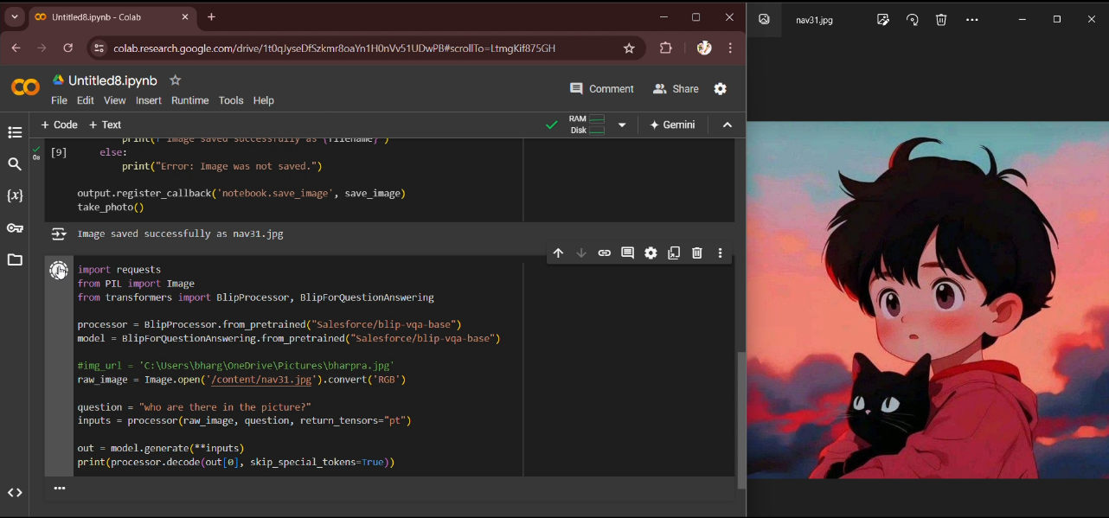

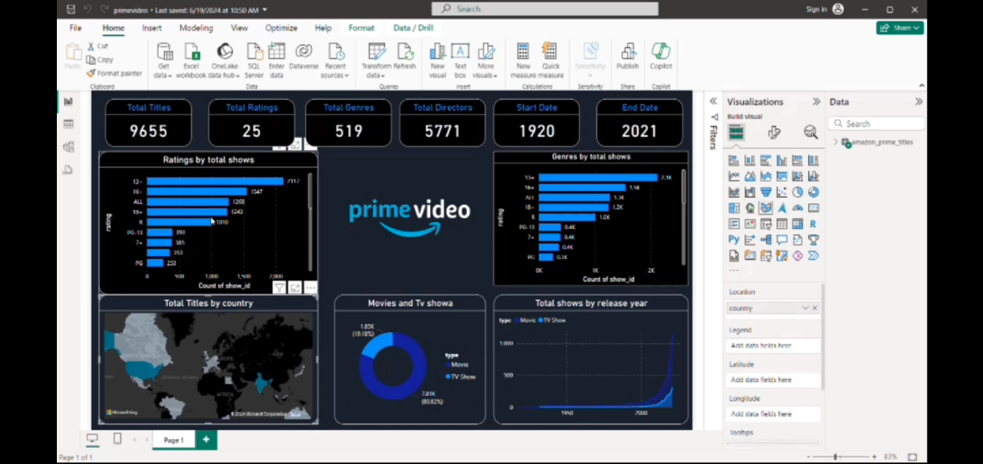

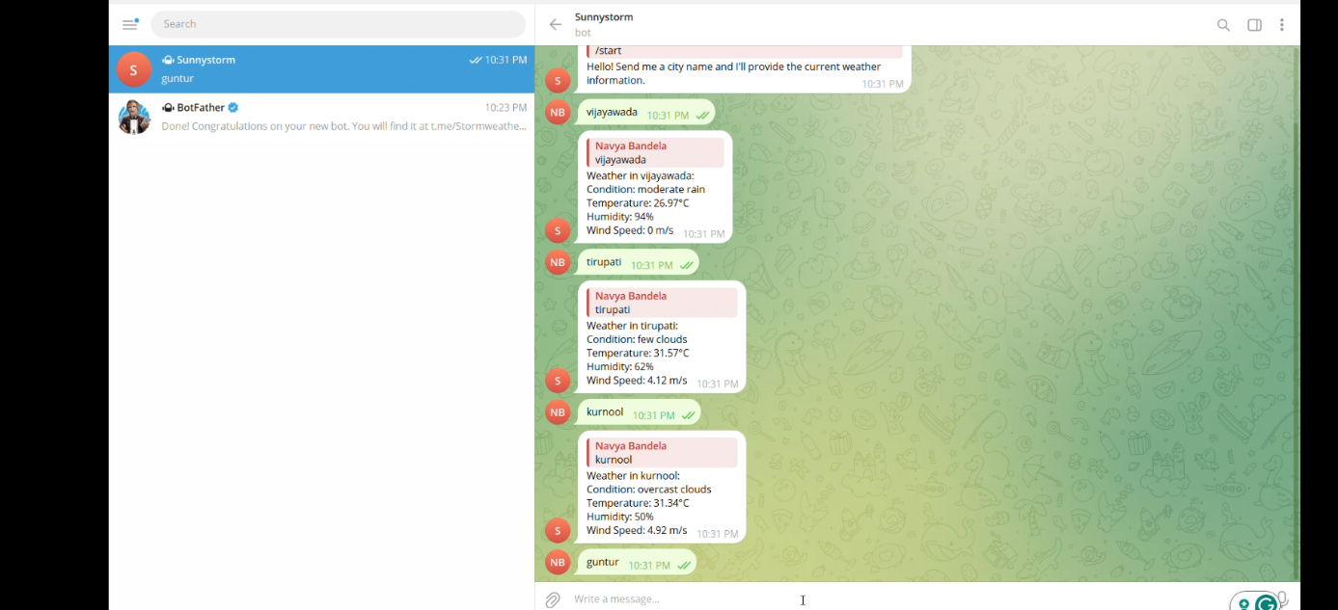

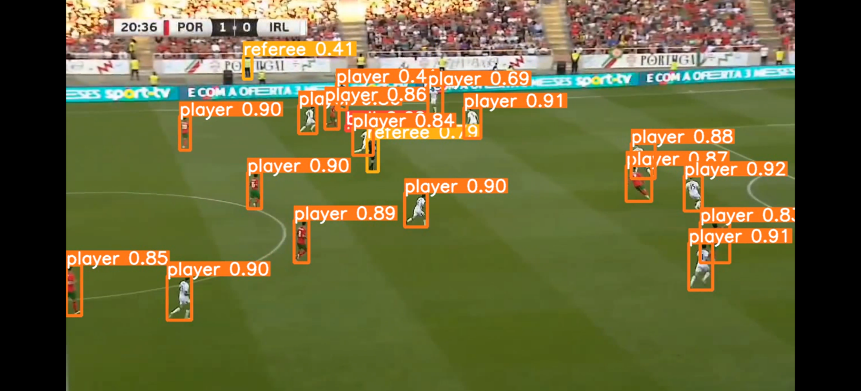

**TASKS LINKS :**

|  |  |  |
| --- | --- | --- |
| **No** | **Description** | **Link** |
|  | A Prime video Power BI dashboard visually displays key metrics such as subscriber growth, viewing hours, and revenue. It includes interactive charts and graphs to analyze trends in content performance and user engagement. This tool aids in making data-driven decisions to enhance content strategy and business operations. | <https://www.linkedin.com/posts/navya-bandila-615812315_powerbi-datavisualization-primevideo-activity-7210501978072764416-RaY4?utm_source=share&utm_medium=member_desktop> |
|  | YOLO (You Only Look Once) is a fast and accurate real-time object detection algorithm that identifies and classifies objects within images or videos using a single neural network | <https://www.linkedin.com/posts/navya-bandila-615812315_yolov8-objectdetection-deeplearning-activity-7210504720270970880-qmKH?utm_source=share&utm_medium=member_desktop> |
| **3.** | A weather Telegram bot delivers real-time weather updates and alerts directly in the Telegram app. It helps users stay informed about weather conditions for their chosen locations. | <https://www.linkedin.com/posts/navya-bandila-615812315_telegrambot-weatherbot-apidevelopment-activity-7210507478797586432-sHHK?utm_source=share&utm_medium=member_desktop> |
| **4.** | A Visual Question Answering (VQA) model is an AI that looks at pictures and answers questions about them. For example, if you show it a photo of a dog and ask, "What animal is in the picture?" it will answer, "dog." It helps in areas like healthcare, education, and helping visually impaired people understand images. | <https://www.linkedin.com/posts/navya-bandila-615812315_vqa-visualquestionanswering-ai-activity-7210516398131859456-2TvF?utm_source=share&utm_medium=member_desktop> |

# Student Self-Evaluation of the Short-Term Internship

|  |
| --- |
| **Student Name:** BANDELA NAVYA |
| **Registration No:** 22551A0577 |
| **Term of Internship:** 8 Weeks |
| **From:** 15-05-2024 **To:** 15-07-2024 |
| **Date of Evaluation:** |
| **Organization Name & Address:** Artificial Intelligence Medical and Engineering Researchers Society (AIMER Society), Vinayaka Temple Roads, Shri Ramchandra Nagar, Vijayawada, Krishna, Andhra Pradesh – 520008 |

**Please rate your performance in the following areas:**

**Rating Scale: Letter grade of CGPA calculation to be provided**

|  |  |  |  |  |  |
| --- | --- | --- | --- | --- | --- |
| 1 Oral communication | 1 | 2 | 3 | 4 | 5 |
| 2 Written communications | 1 | 2 | 3 | 4 | 5 |
| 3 Proactiveness | 1 | 2 | 3 | 4 | 5 |
| 4 Interaction ability with community | 1 | 2 | 3 | 4 | 5 |
| 5 Positive Attitude | 1 | 2 | 3 | 4 | 5 |
| 6 Self-confidence | 1 | 2 | 3 | 4 | 5 |
| 7 Ability to learn | 1 | 2 | 3 | 4 | 5 |
| 8 Work Plan and organization | 1 | 2 | 3 | 4 | 5 |
| 9 Professionalism | 1 | 2 | 3 | 4 | 5 |
| 10 Creativity | 1 | 2 | 3 | 4 | 5 |
| 11 Quality of work done | 1 | 2 | 3 | 4 | 5 |
| 12 Time Management | 1 | 2 | 3 | 4 | 5 |
| 13 Understanding the Community | 1 | 2 | 3 | 4 | 5 |
| 14 Achievement of Desired Outcomes | 1 | 2 | 3 | 4 | 5 |
| **15 OVERALL PERFORMANCE** | **1** | **2** | **3** | **4** | **5** |

**Date: Signature of the Student**

**Evaluation by the Supervisor of the Intern Organization**

**Student Name:** BANDELA NAVYA

**Registration No:** 22551A0577

**Term of Internship:** 8 weeks

**From:** 15-05-2024

**To:** 15-07-2024

**Date of Evaluation:**

**Organization Name & Address:** Artificial Intelligence Medical and Engineering Researchers Society (AIMER Society), Vinayaka Temple Roads, Shri Ramchandra Nagar, Vijayawada, Krishna, Andhra Pradesh – 520008

**Name & Address of the Supervisor with Mobile Number:** Ms. N. SINDHURI & GIET(A)

Please rate the student’s performance in the following areas:

Please note that your evaluation shall be done independently of the student’s self-evaluation.

Rating Scale: 1 is the lowest and 5 is the highest rank

|  |  |  |  |  |  |
| --- | --- | --- | --- | --- | --- |
| 1 Oral communication | 1 | 2 | 3 | 4 | 5 |
| 2 Written communications | 1 | 2 | 3 | 4 | 5 |
| 3 Proactiveness | 1 | 2 | 3 | 4 | 5 |
| 4 Interaction ability with the community | 1 | 2 | 3 | 4 | 5 |
| 5 Positive Attitude | 1 | 2 | 3 | 4 | 5 |
| 6 Self-confidence | 1 | 2 | 3 | 4 | 5 |
| 7 Ability to learn | 1 | 2 | 3 | 4 | 5 |
| 8 Work Plan and Organization | 1 | 2 | 3 | 4 | 5 |
| 9 Professionalism | 1 | 2 | 3 | 4 | 5 |
| 10 Creativity | 1 | 2 | 3 | 4 | 5 |
| 11 Quality of work done | 1 | 2 | 3 | 4 | 5 |
| 12 Time Management | 1 | 2 | 3 | 4 | 5 |
| 13 Understanding the Community | 1 | 2 | 3 | 4 | 5 |
| 14 Achievement of Desired Outcomes | 1 | 2 | 3 | 4 | 5 |
| **15 OVERALL PERFORMANCE** | **1** | **2** | **3** | **4** | **5** |

**Date: Signature of the Supervisor**

**INTERNAL ASSESSMENT STATEMENT**

**Name Of the Student:**  BANDELA NAVYA

**Programmer of Study:** Bachelor of Technology

**Year of Study:** 3rd Year

**Group:** Computer Science and Engineering

**Register No/H.T. No:** 22551A0577

**Name of the College:** Godavari Institute of Engineering & Technology(A**)**

|  |  |  |  |
| --- | --- | --- | --- |
| ***Sl.No*** | **Evaluation Criterion** | **Maximum Marks** | **Marks Awarded** |
| **1.** | **Activity Log** | **25** |  |
| **2.** | **Internship Evaluation** | **50** |  |
| **3.** | **Oral Presentation** | **25** |  |
|  | **GRAND TOTAL** | **100** |  |

Date: **Signature of the Faculty Guide**

### Certified by

Date:  **Signature of the Head of the Department/Principal**

Seal: